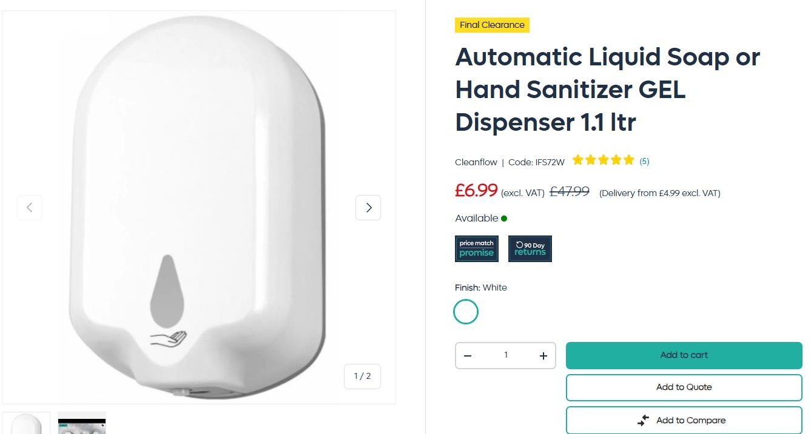

5,238pcs x Cleanflow 1.1L Auto Soap Dispenser Gel/White………….Original RRP £47.99

3,931pcs x Cleanflow 1.1L Auto Soap Dispenser Spray/White……….Original RRP £47.99

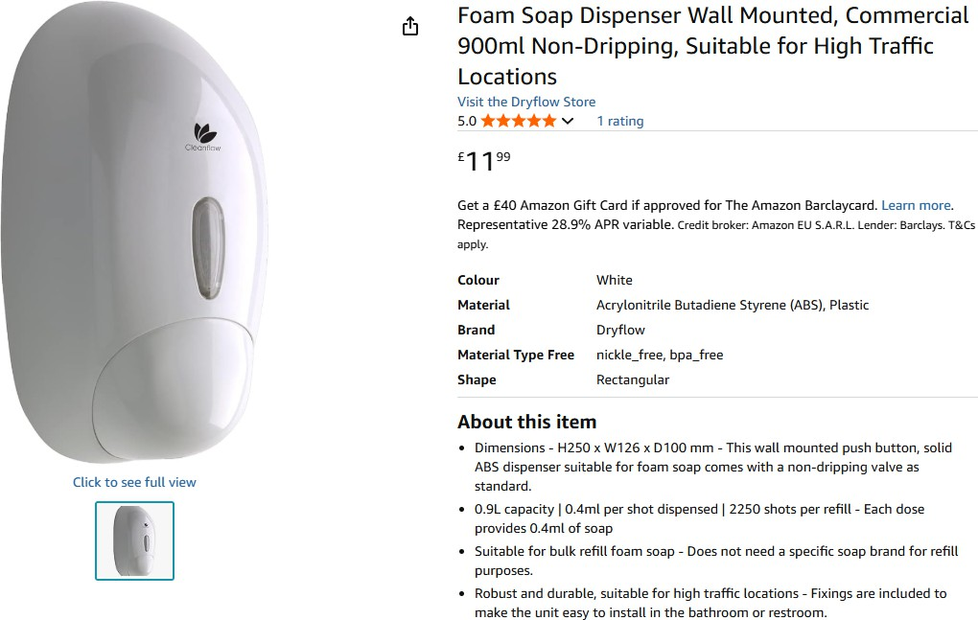

3,343pcs x Cleanflow Soap Dispenser Wall Mounted, Commerical 900ml Non-Dripping Suitable for High Traffic Selling on amazon

for £11.99

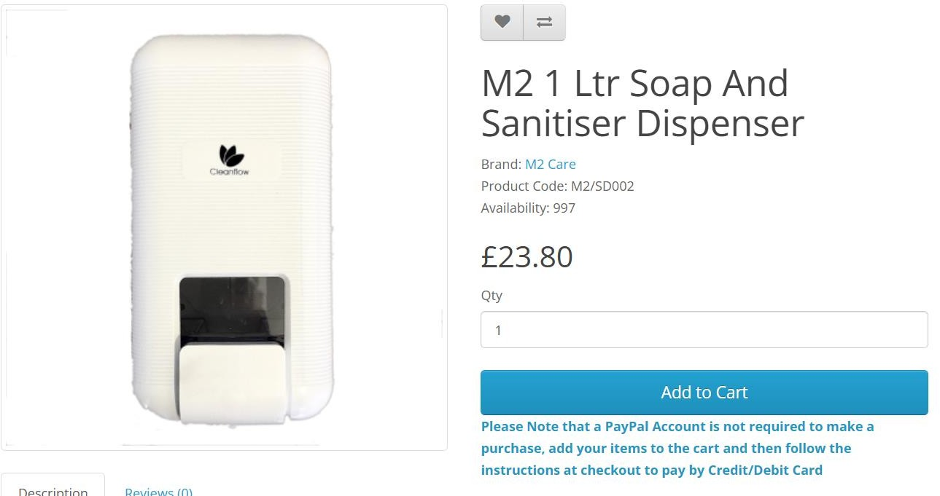

1,040pcs x Cleanflow 1Ltr Soap C Sanitiser Dispenser………..RRP £23.80

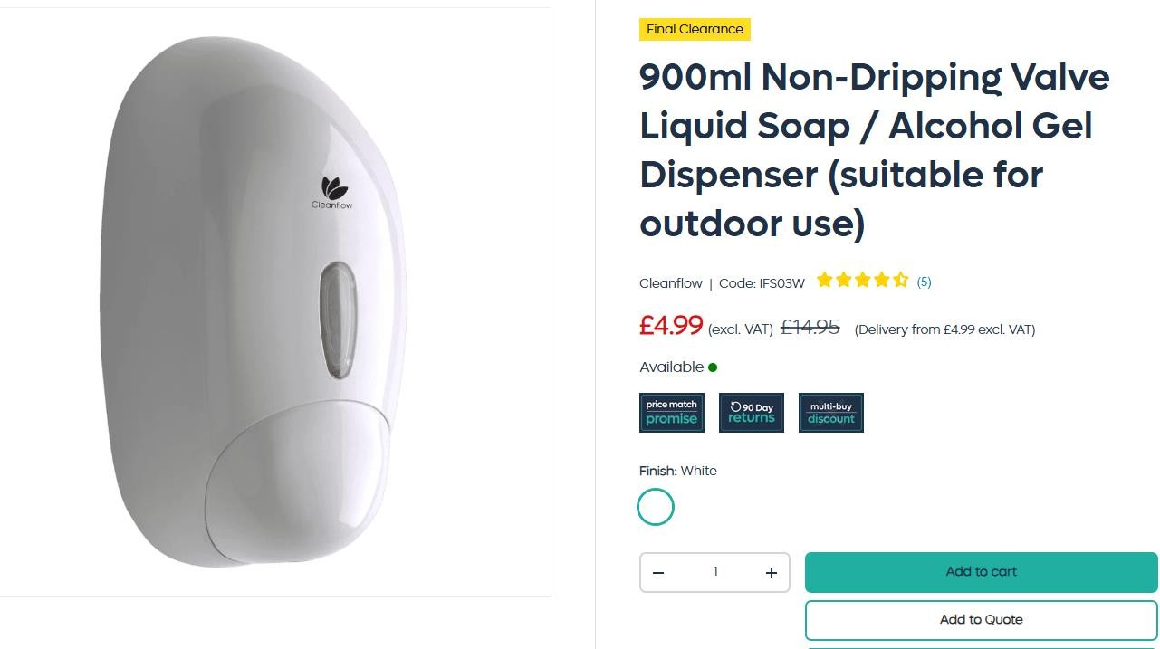

795pcs x Cleanflow 900ml Non-Dripping Valve Liquid Soap C Gel Dispenser………..Original RRP £14.95

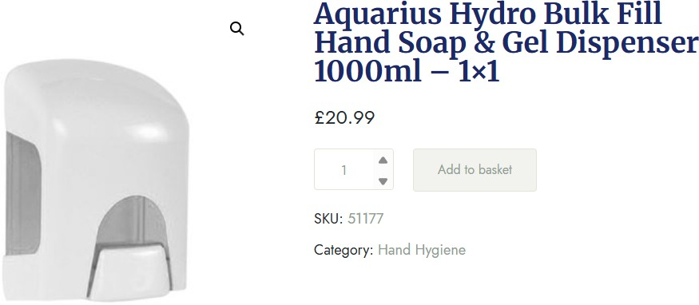

378pcs x Hydo Bulk Fill Hand Soap C Gel Dispenser 1000ml………..RRP £20.99

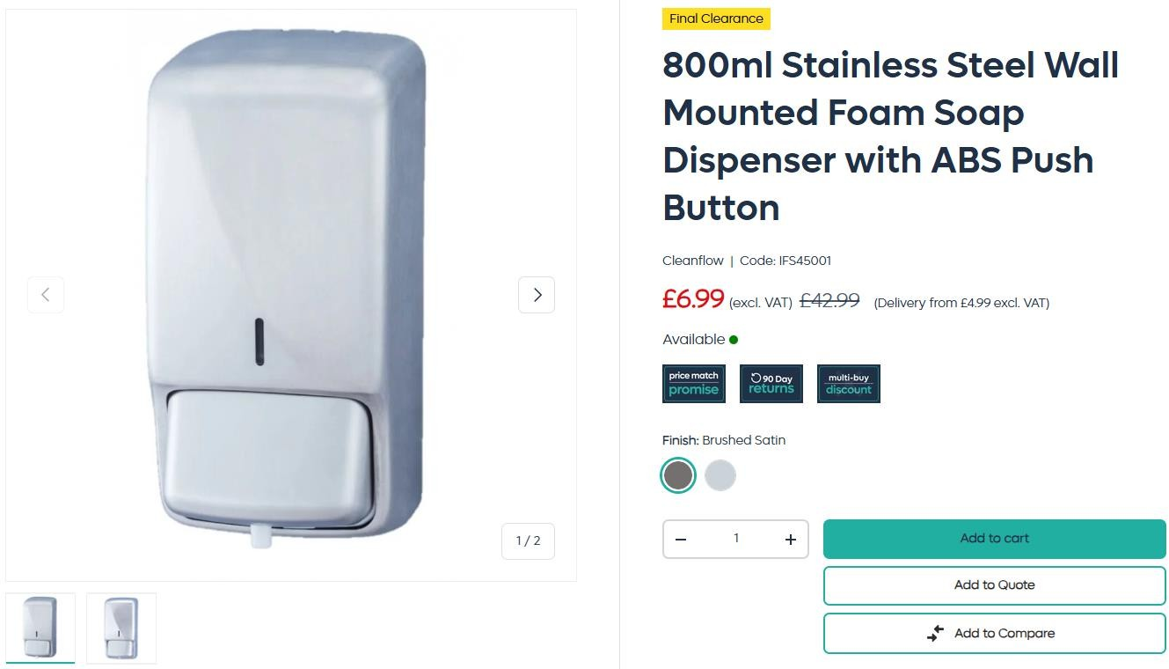

120pcs x 800ML Stainless Steel Wall Mounted Foam Soap Dispenser………..Original RRP £42.99